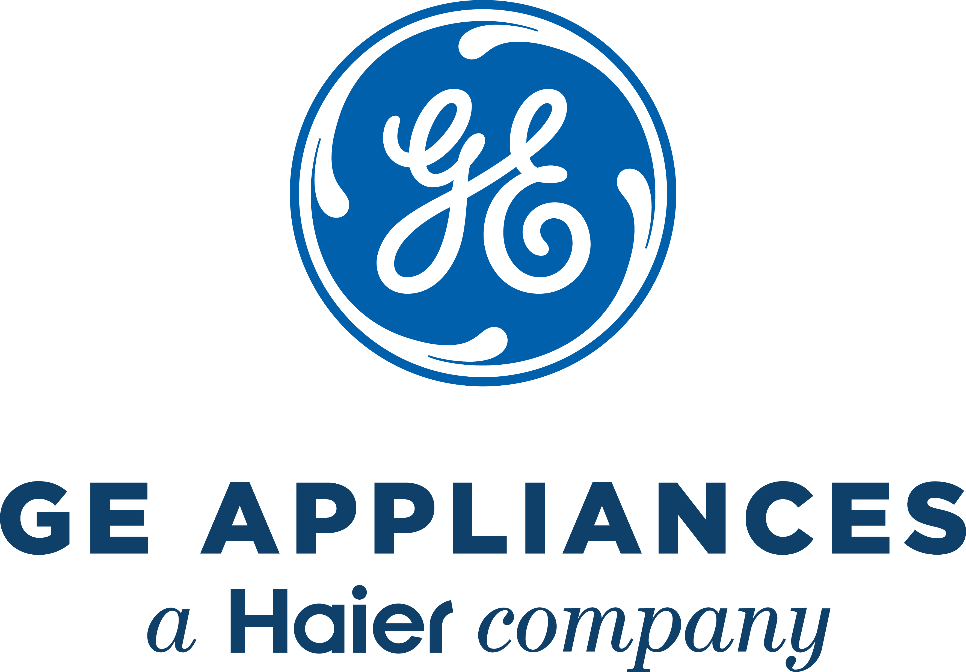
2024 Appliance Park Contract Negotiations Fact Sheet

Overview
In 2024, GE Appliances will negotiate a new collective bargaining agreement with IUE-CWA Local 83761 who represents approximately 5,200 production employees at Appliance Park in Louisville, Ky. Negotiations will take place in Louisville.

Negotiations this year will also include boiler house employees in SEIU-NCFO 320 located at the Park.

We are committed to working together with the IUE-CWA and SEIU-NCFO to negotiate fair contracts that recognize employee contributions and allow the company to continue to reinvest in our future.

Timing
The current collective bargaining agreement expires on December 31, 2024. Negotiations will begin on October 14, 2024.

Topics
Topics will include the state of the industry, wages, healthcare, other benefits and work practices.

Voting/Ratification
Each union involved will hold a vote for their local union members. When a majority of members (50% + 1) vote to accept the agreement, it becomes ratified and takes effect on the agreed-upon date.

